**Student Rankings Manual**

**(Left side view - Search Options)**

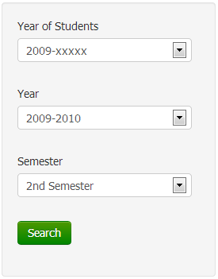

The left side view of this module contains the searching options of the module. When the search button is pressed, the module displays the students based on the options selected.

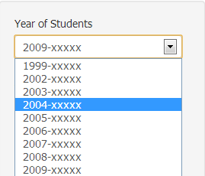

The option ‘Year of Students’ is a dropdown box containing all possible given years of the students with respect to the data uploaded.

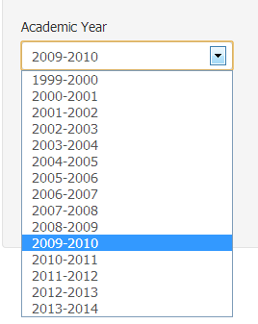

The option ‘Academic Year’ is a dropdown box containing all the possible academic years with respect to the data uploaded.

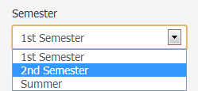

The option ‘Semester’ is a dropdown box containing all the semesters with respect to the data uploaded.

**(Right side view- Students’ Table Display)**

The right side of the module contains the ”Download CSV” button, the display option for students and the table displaying the student number, name, GWA, CWA, CS GWA, Math GWA of the students per semester depending on the year and semester selected at the search options.

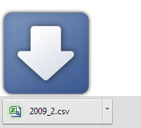

**Generate CSV**

When the Download CSV button is pressed, a CSV file containing the table found on the view is downloaded on the browser.

**Table Display:**

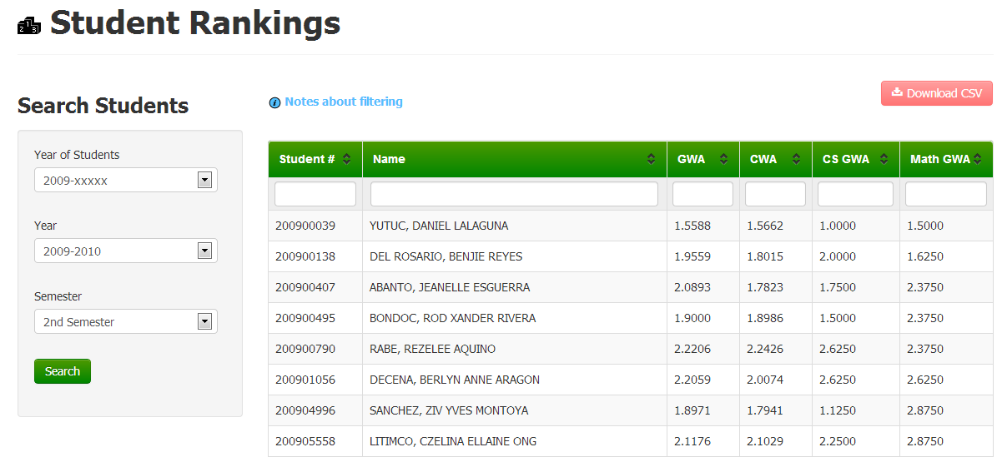

* The table displays the student number, name, GWA, CWA, CS GWA, Math GWA of the students up until the semester that was selected

**Search Bars:**

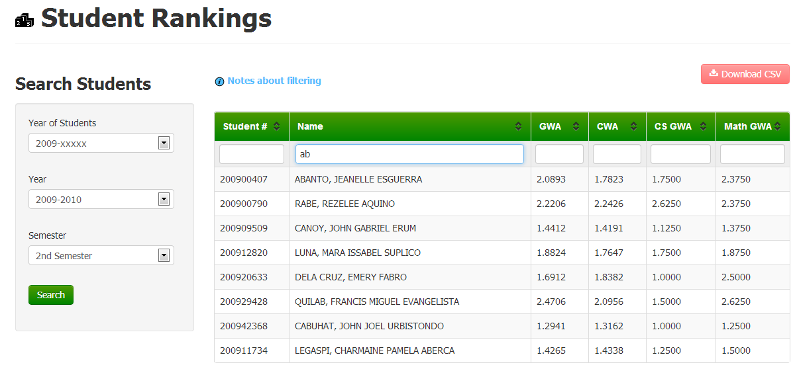

* The blank bars found below the column names are search bars.

Example: By typing “ab” on the search bar on the ‘name’ column, all names having a substring “ab” will be displayed.

**Table Sorter:**

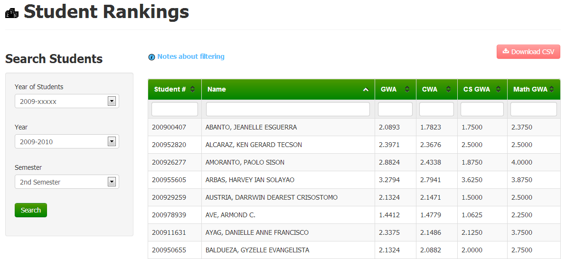

* Data on the table can be sorted using its columns in the table. One press sorts the table by ascending order and two presses sort the table by descending order with respect to the column attribute pressed.

Example: The above screenshot is sorted by name, ascending order.